Defintions and Rules for Establishment Planning Project

Assumptions

All crew are LGW based

If any pairings are made which do not start or finish in LGW, make a “TAXI” duty which lasts for 4 hours and connects the captain back to his base.

All airport 3 letter codes can be found on the internet

Each departure needs one Captain on standby – from 2 hours before pairing start until 2 hours after pairing start. Rules for early / late duties apply to standbys.

Definitions
Unless otherwise defined below all words, phrases, definitions and abbreviations, have identical meanings to those described in Article 155 of the Air Navigation Order 2005.
7.1.5.2 Block Time
Commences from chocks away to engine shutdown on completion of a flight.
7.1.5.6 Days Off
Periods available for leisure and relaxation free from all duties.
A single day off shall include two local nights and be a minimum of 34 hours. Consecutive days off shall include a further local night for each additional consecutive day off. A rest period may be included as part of a day off.

7.1.5.7 Duty/Duty Period
Any continuous period during which a crew member is required to carry out any task associated with the business of the Company. Such tasks include operating as crew member, or as a passenger and include a flying duty period, positioning by any means, ground training, ground or standby duties.

7.1.5.8 Early Start Duty
A duty is an Early Start Duty if it commences in the period 0100 to 0659 hours local time.

7.1.5.10 Flying Duty Period (FDP)
Any duty period during which a crew member operates in an aircraft and includes pre-flight preparation. It starts when the crew member is required by the Company to report for a flight and finishes when the aircraft parks on stand after the final sector.
Note: A Duty period or FDP is continuous unless broken by a period of minimum rest.

7.1.5.11 Late Finish Duty
A duty is a Late Finish when the duty finishes in the period 0100 to 0159 hours local time.

7.1.5.12 Local Night
A period of 8 hours falling between 2200 hours and 0800 hours local time.
7.1.5.13 Night Duty
A duty is a Night Duty if any part of that duty falls within the period 0200 to 0459 local time.
7.1.5.16 Reporting Time
The time at which a crew member is required by the Company to report for any duty.
7.1.5.17 Rest Period
A period of time before starting a flying duty period which is designed to give crew members adequate opportunity to rest before a flight.
7.1.5.21 Sector
The time between an aircraft first moving under its own power until it next comes to rest after landing on the designated parking position.
7.1.5.23 Standby Duty
A period during which a crew member must be available to report within an agreed time for any duty required by the company. A standby period shall not be treated as a Contactable defined above. Once a standby has started a crew member may be contacted with notice of a change of duty, however, the standby cannot be reduced to bring forward a rest period to allow a report time less than 12 hours from the end of the planned standby period.
7.1.5.24 Suitable Accommodation
A well furnished bedroom which is subject to minimum noise, is well ventilated, and has the facility to adjust the levels of light and temperature.
7.1.5.25 Travelling
All time spent by a crew member in transit between the place of rest, and the place of reporting for duty.

Rules

How to measure duty, flying duty and report times

Duty Period starts from report time until the end of the very last activity

Flying Duty Period starts at report time until last landing time

Remember that Duty and Flying Duty are different concepts. Duty is any activity the crew member undertakes, while a Flying Duty must include an active flight.
Duty and FDP both start at the same time, but duty extends after the last landing time to allow completion of paperwork, positioning to another base or any other activity we may require.
FDP ends when the crew are no longer responsible for the safety of passengers – when they hand over to ground staff after the last sector.

TIME |  | 0800 | 0930 | 1000 | 1100 | 1200 | 1300 | 1400 | 1500 | 1600 | 17 | 00 | 1800 | 1900 | 2000
SECTORS |  |  |  | LGW |  | PMI |  | PMI |  | LGW
REPORT |  |  | -30 mins
DUTY |  |  | Report |  |  |  |  |  |  | +30 min
FDP |  |  | Report |  |  |  |  | last | Landing

Report Times

Pilots report 30 mins before departure
Duty finishes 30 minutes after last landing time

Calculating the FDP – Flying Duty Period

Take the report time in local, and then add the hours depending on how many sectors are flown. This is added to the report time in GMT to discover the last legal landing time. This can not be extended in the planning stage.

 | Sectors
Local time of start | 1 | 2 | 3 | 4 | 5 | 6 | 7 | 8+
0600-0759 | 13:00 | 12:15 | 11:30 | 10:45 | 10:00 | 9:30 | 9:00 | 9:00
0800-1259 | 14:00 | 13:15 | 12:30 | 11:45 | 11:00 | 10:30 | 10:00 | 9:30
1300-1759 | 13:00 | 12:15 | 11:30 | 10:45 | 10:00 | 9:30 | 9:00 | 9:00
1800-2159 | 12:00 | 11:15 | 10:30 | 9:45 | 9:00 | 9:00 | 9:00 | 9:00
2200-0559 | 11:00 | 10:15 | 9;30 | 9:00 | 9:00 | 9:00 | 9:00 | 9:00

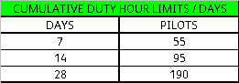

Absolute limit on Flying Hours for pilots is 105 hrs in 28 consecutive days, they cannot take off after 105 hrs.

Days Off
1 day off = 34 hrs with 2 local nights
Remember, a local night is between 2200 and 0800 with 8 hrs.
Crew must have 1 day off in 9 days and 2 days off in 14 days.
Need a minimum of 7 days off in 4 weeks but need an average of 8 days off every 3 months.
Earliest crew can start after a day off is 0600 local.

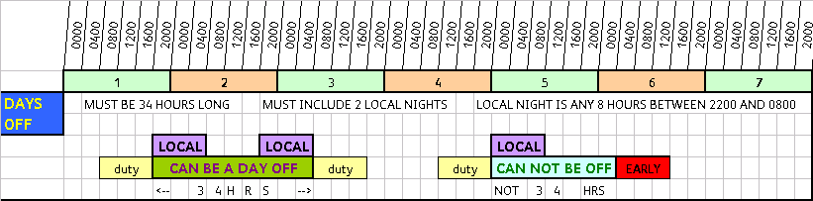
Early and Late Flights

E/L = 0100 – 0659 LOCAL TIME

Can only do 3 consecutive lates or 4 lates in 7 days if not all consecutive.
Can do 3 consecutive earlys or 4 early's in 7 days if not all consecutive.

If you are planning 2 or 3 consecutive early duties, then the crew member must have a day off before. Remember the local night means that they should have a day off, then a day with no duty, then the earlies… you can’t call it a local night if they are reporting before 0600.

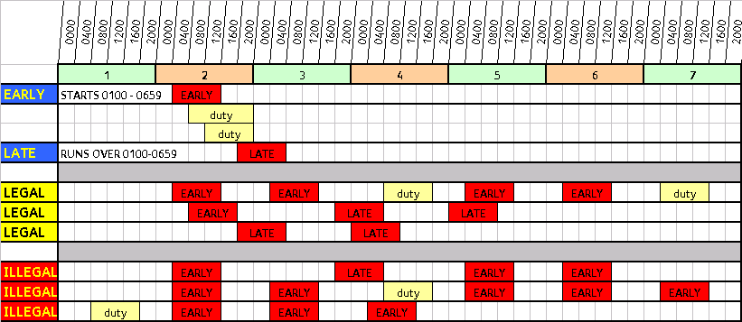

(Error in picture above: 1st “Legal” isn’t, as no day off before consecutive early’s)

Rest Periods

The rest period between any two duties should be a minimum of

12 HOURS
Or
AT LEAST AS LONG AS THE PRECEEDING DUTY

